Cryptocurrency Price Prediction

Md. Fahim Hasnat
BRAC University
14101043
Md. Mazidul Hasan
BRAC University
14301104
Md. Golam Kibria Ripan
BRAC University
16241017
Hasin Raihan
BRAC University
13301102

Abstract— Cryptocurrencies, especially Bitcoin, have been one of the top hit in social media and search engines recently. Unfortunately, due to their lack of indexes, Cryptocurrencies are relatively unpredictable compared to traditional financial instruments. While there has been significant research done to analyze the network topology of the Bitcoin network, limited research has been performed to analyze the network’s influence on overall Bitcoin price. This research is concerned with predicting the price of Bitcoin using machine learning. This paper explores the association between Bitcoin’s market price and a set of internal and external factors using Convolutional Neural Network(CNN) and Long Short-Term Memory(LSTM).
Keywords—Bitcoin;Learning;Prediction;Increment;Decrement.

Introduction
Bitcoin is a cryptographic protocol and distributed network that enables users to, store, and transfer digital currency. The scheme was first implemented by Satoshi Nakamoto in January 2009. Based on the transparency and security of the Bitcoin protocol, the Bitcoin ecosystem has gained significant traction from consumers, businesses, speculators and investors.
Digital coins or cryptocurrencies, named in such way due to their characteristic of using encryption systems that regulate the creation of coins and transfers have to be identified from an economic analysis perspective. Hence, it is important to examine which social, financial and macroeconomic factors determine its price in order to know the scope and consequences of the economy. The goal of this paper is to explore the implication of search trends as a proxy for interest, macro-financial and internal factors that impact the price. One the main contributions of this study are that it will follow the structural time series approach that allows disaggregating the series in their different components, moreover, they have the ability to let the coefficients vary over time permitting the estimation of sensitivities of different factors or structural changes due to significant events. None of the existent research has accounted for the differentiation of the elements that have dealt with the price dynamics over the time and the possibility that this digital coin is entering a different stage. Moreover, the condition that the search trend and magnitude vary greatly across countries has not been accounted yet, in that sense, this study innovates by applying data-driven methods to specify which groups of search trends have a relevant relationship with Bitcoin price.

Methods

Data Collection
Data collected from source needs to be parsed in order to send to the model for prediction. The collection of data was done by simple requesting file from polonix.com. The PastSampler class was referenced from this site for splitting the data into a list of datas and labels. This site contains live data of several cryptocurrencies. We only fetched data of Bitcoins and Ethereums from 2015 to 2017. We have several columns having date, high, low, open, close and volume. Here date means data showing of which day, high signifies what is the highest value rise of that day. Low signifies how much low does it goes on that same day. Open and close signifies the price when the market opens and closes and Volume is how many currencies was exchanged on same day period.

Data Preparation
Here we only used close column. By only Closing price of two different days we can represent how much price increases or decreases. So, we only save the file by h5py module, which makes .h5 format. Here we got 324294 rows of Bitcoins and 278075 rows of Ethereum.

CNN
A convolutional neural network (CNN) was used to predic the future price. CNNs are a fundamental example of deep learning, where a more sophisticated model pushes the evolution of artificial intelligence by offering systems that simulate different types of biological human brain activity. A 1D Convolutional Neural Network is expected to capture the data locality well with the kernel sliding across the input data.
As shown in the following figure.
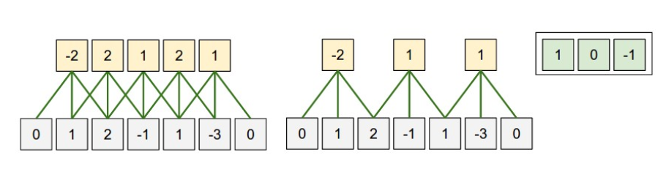
The code for constructing CNN model was very simple. The dropout layer is for preventing overfitting problem. The loss function is defined as Mean Squared Error (MSE), while the optimizer is the state-of-the-art Adam. At the end of the file, we added two callback functions, CSVLogger, and ModelCheckpoint. The former one helps to track all the training and validation progress, while the latter one allows us to store the model’s weight for each epoch.

LSTM
Long Short-Term Memory networks – usually just called “LSTMs” – are a special kind of RNN, capable of learning long-term dependencies. LSTMs are explicitly designed to avoid the long-term dependency problem. All recurrent neural networks have the form of a chain of repeating modules of neural network. In standard RNNs, this repeating module will have a very simple structure, such as a single tanh layer. LSTMs also have this chain like structure, but the repeating module has a different structure. Instead of having a single neural network layer, there are four, interacting in a very special way
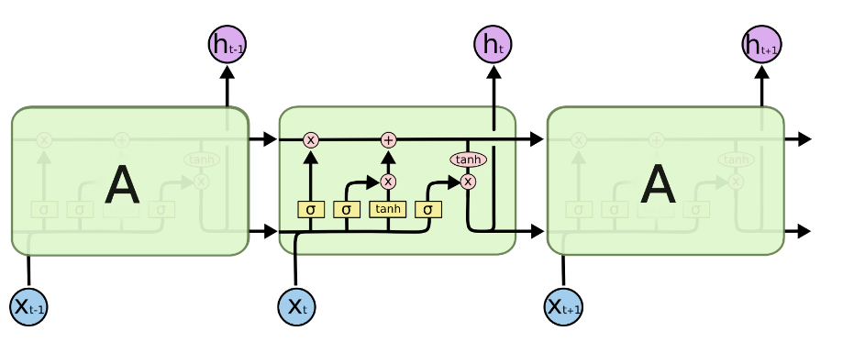
LSTM is relatively easier than CNN to implement as we don’t even need to care about the relationship among kernel size, strides, input size and output size. We make sure the dimension of input and output is defined correctly in the network

Results
We have run two algorithms with our two data sets to get the result and finally stick with the best one from them. With some discrepancies both CNN and LSTM gave excellent predictions but LSTM was more precise with its accuracy.

Prediction results for CNN:
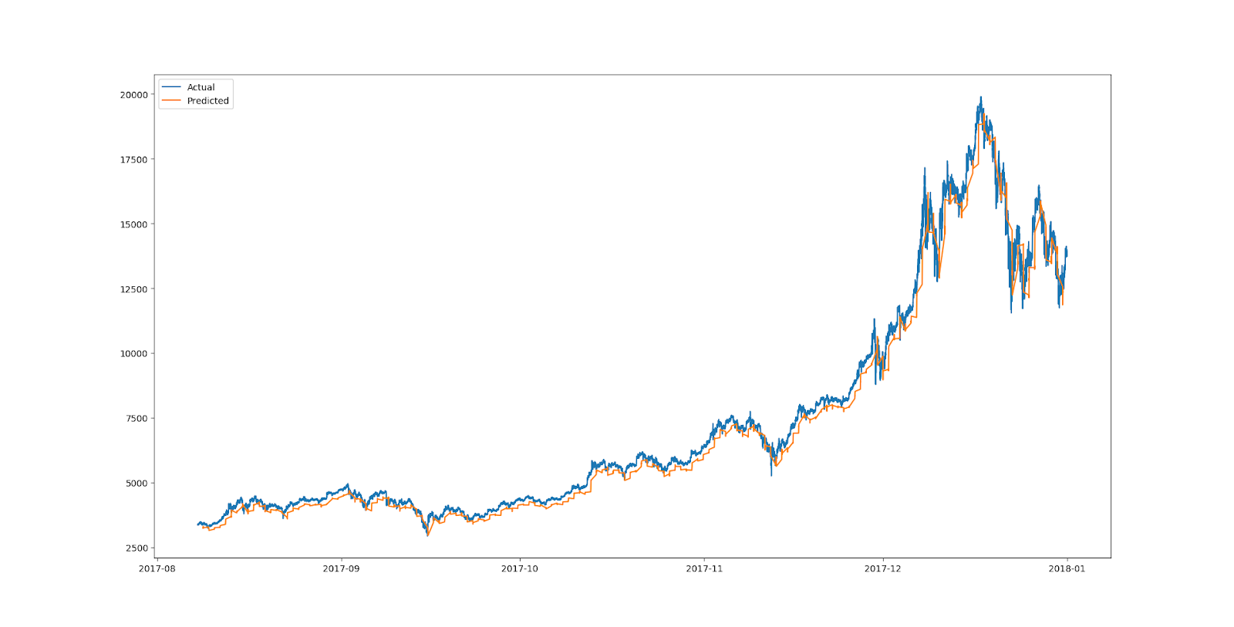 Fig. 1. Prediction graph for Bitcoin.

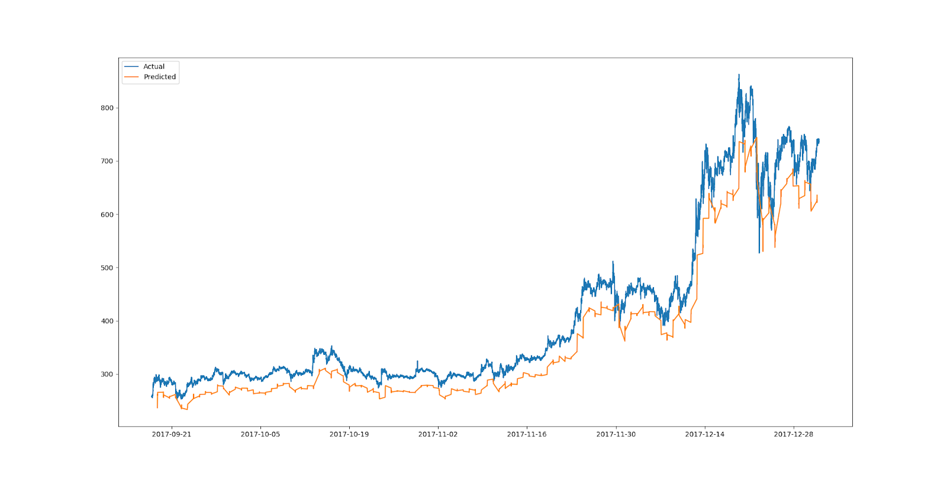

Fig. 2. Prediction graph for Ethereum.

Prediction results for LSTM:

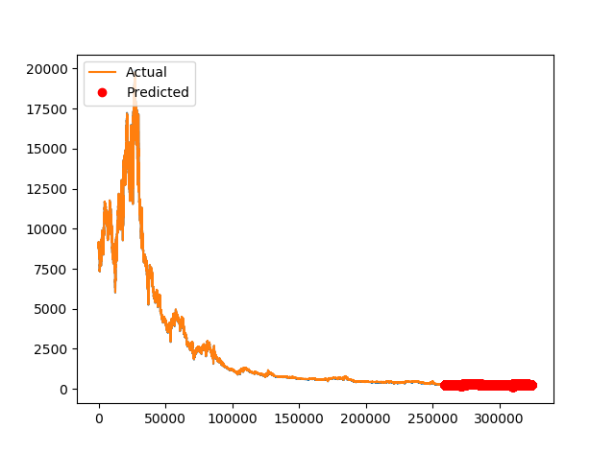
Fig. 3. Prediction graph for Ethereum.
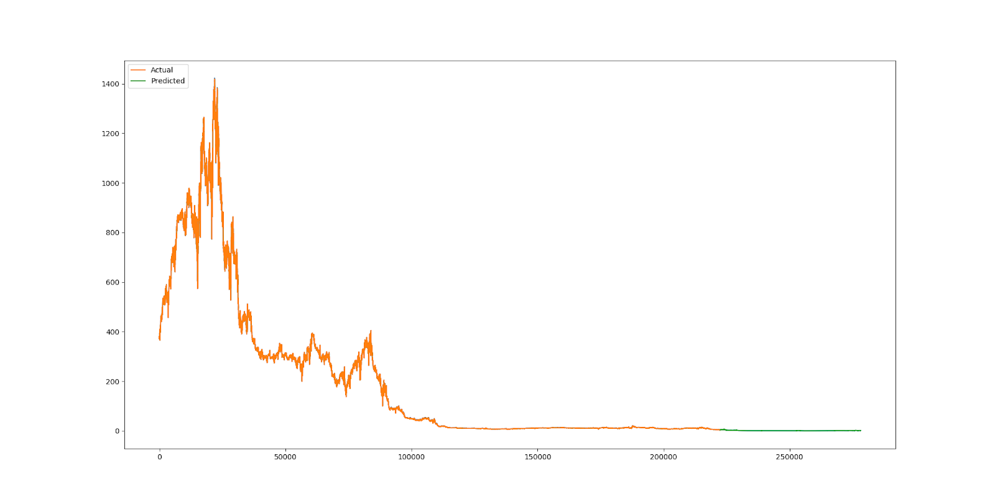

Fig. 4. Prediction graph for Ethereum.

These figures will give you the perfect insight about the actual price and the predicted price for both bitcoin and Ethereum. LSTM produced more accurate results from our data set than CNN. The system follows something more like the moving average concept as the prices are changing every now and then.

Discussion
The cryptocurrency market warrants close scrutiny given its increasingly high profile. The sums of money involved are substantial. The total cryptocurrency market capitalization is estimated to be $7.1 billion (www.coinmarketcap.com, January 2016). Amongst over 600 traded cryptocurrencies Bitcoin and Ripple are the two most popular cryptocurrencies with around 91% and 2.8% of the entire cryptocurrency market capitalization.

Machine learning algorithm can easily detect the pattern of the market price. At least it can give a great probability of a falling or rising price. Our results show a clear relationship among time and price. Bitcoin and Ethereum prediction graphs are somewhat same. LSTM was overfit with only 5 epoch. This behavior of LSTM was unexpected. Our model’s such high accuracy was unexpected. Now we know LSTM is the one of the best algorithm to predict cryptocurrency market prices. This result will help millions of people to face less loss in investing if heavy research goes on this area.

Conclusion

We want to conclude that by using modern technology we are able to predict the nature of crypto currencies which are considered as one of the most unpredictable financial instruments among the other candidates. The study was interesting and also thought provoking which allowed us a unique understanding. With proper tools and perfect preparation of them we can really enjoy the benefits of our modern technology. There are other unpredictable and unstable branches with huge potential to contribute for the well-being of human civilization. This study should inspire them to achieve their goals no matter how hard they appear. So, this is not a study for investors to put their money in the right spot but rather a case study. We want to warn our readers about fully rely on machine learning to predict tomorrows price. There was a devastating downfall in 2018 of market price of bitcoin. Now it considers as a dead coin and hoping to regain its value.

References

- Li, X. and Wang, C. (2017). The technology and economic determinants of cryptocurrency exchange rates: The case of Bitcoin. Decision Support Systems, 95, pp.49-60.
- Fry, J. and Cheah, E. (2016). Negative bubbles and shocks in cryptocurrency markets. International Review of Financial Analysis, 47, pp.343-352.
- http://snap.stanford.edu/class/cs224w-2015/projects_2015/Using_the_Bitcoin_Transaction_Graph_to_Predict_the_Price_of_Bitcoin.pdf
- http://trap.ncirl.ie/2496/1/seanmcnally.pdf

- http://journals.plos.org/plosone/article?id=10.1371/journal.pone.0161197

- http://jibfnet.com/vol-3-no-1-june-2015-abstract-1-jibf

